**SQL PORTFOLIO PROJECT**

**FOODIE – FI CASE STUDY**

**BY AMNA BIBI**

**INTRODUCTION:**

Foodie-Fi is a website where one can sign up to watch many cooking related shows from all over the world. Danny, who launched Foodie-Fi with few smart friends and started selling monthly and annual subscriptions, giving their customers unlimited on-demand access to exclusive food videos.

Danny created Foodie-Fi with a data driven mindset and wanted to ensure all future investment decisions and new features were decided according to what people desire to watch and what they like.

Therefore needed to analyze the data.

**QUESTION: 1**

**How many customers Foodie-Fi ever had?**

**QUERY:**

**SELECT COUNT(DISTINCT customer_id) AS customer_count**

**FROM subscriptions;**

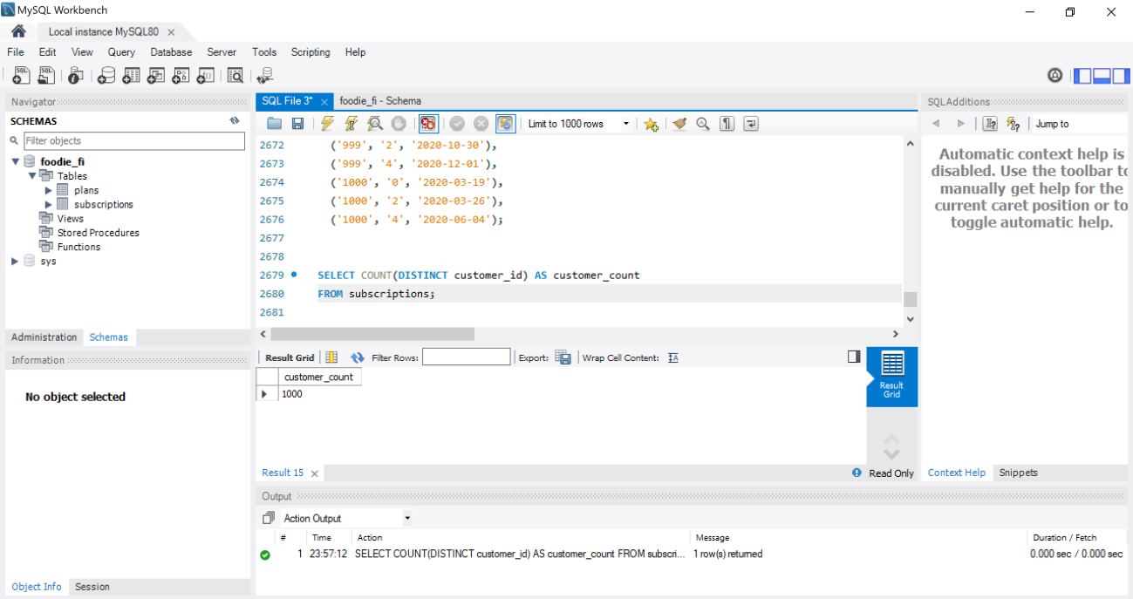

**QUESTION: 2**

**What is the monthly distribution of trial plan start_date values for our dataset - use the start of**

**the month as the group by value.**

**QUERY**

**SELECT plan_id, month(start_date) as month, count(month(start_date)) as count from subscriptions**

**group by month(start_date), plan_id**

**having plan_id=0;**

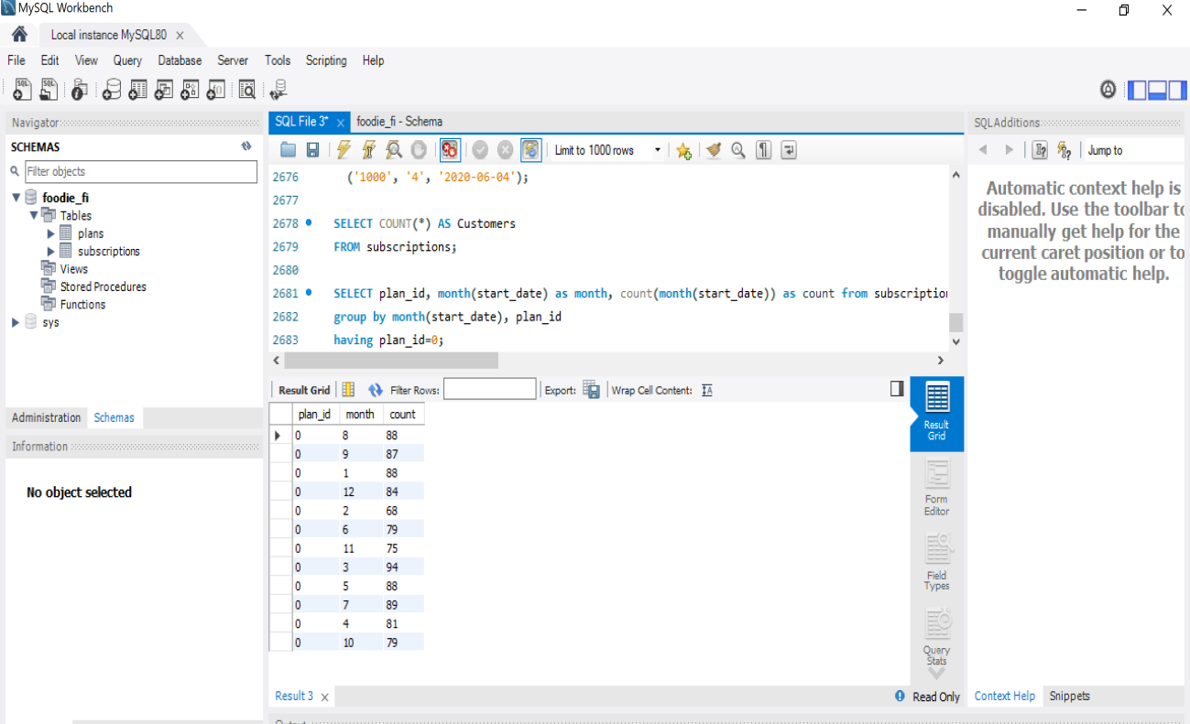

**QUESTION: 3**

**What plan start_date values occur after the year 2020 for our dataset? Show the breakdown by count of**

**events for each plan_name.**

**QUERY**

**SELECT plans.plan_name, sp.plan_id, year(start_date) as year, count(year(start_date))**

**as Count_of_events from subscriptions as sp**

**JOIN plans on sp.plan_id=plans.plan_id**

**where year(start_date)>2020**

**Group by plans.plan_name, plan_id, year(start_date);**

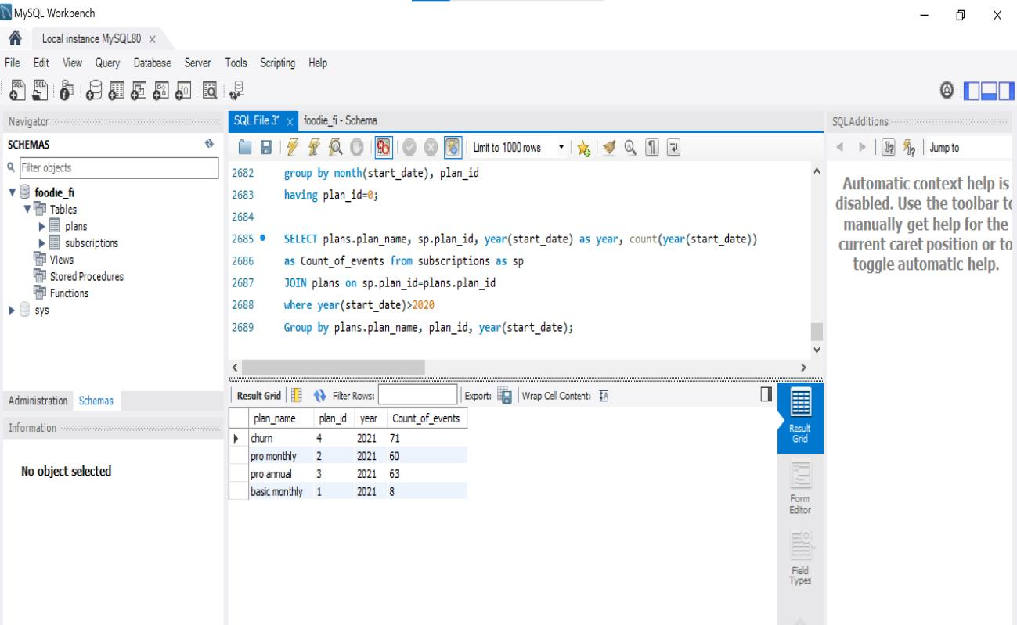

**QUESTION: 4**

**What is the customer count and percentage of customers who have churned rounded to 1**

**decimal place?**

**QUERY**

**select plan_name, count((select count(distinct customer_id) from subscriptions)) as**

**count_of_churned,**

**ROUND(count(plans.plan_name) / (select count(distinct customer_id) from**

**subscriptions),1)*100 as Percentage**

**from subscriptions as sp**

**join plans on sp.plan_id=plans.plan_id**

**where plan_name='churn'**

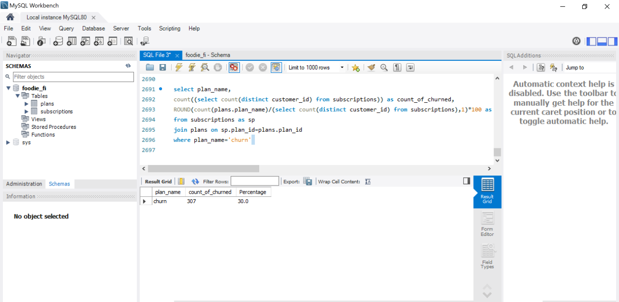

**QUESTION: 5**

**How many customers have churned straight after their initial free trial - what percentage is this**

**rounded to the nearest whole number?**

**QUERY**

**SELECT plan_id,count(customer_id) as count_customer,**

**Round(count(customer_id)/(select count(customer_id) from subscriptions),3)*100 as**

**Percentage**

**from subscriptions where plan_id=4**

**and customer_id in(select customer_id from subscriptions where plan_id=0);**

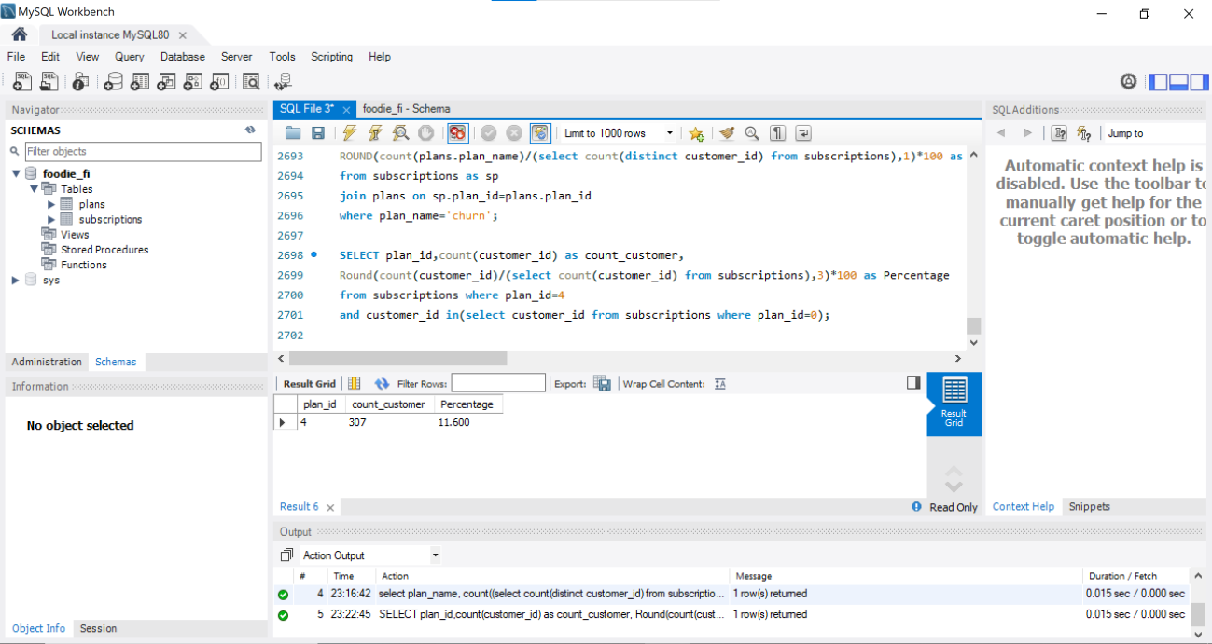

**QUESTION: 6**

**What is the number and percentage of customer plans after their initial free trial?**

**QUERY**

**WITH CustomerFirstPaidPlan AS (**

**SELECT customer_id, MIN(plan_id) AS first_paid_plan_id**

**FROM subscriptions**

**WHERE plan_id != 0 -- Exclude free trial**

**GROUP BY customer_id**

**)**

**SELECT p.plan_name,**

**COUNT(DISTINCT c.customer_id) AS customer_count,**

**ROUND(COUNT(DISTINCT c.customer_id) * 100.0 / (SELECT COUNT(DISTINCT customer_id) FROM**

**subscriptions)) AS percentage**

**FROM CustomerFirstPaidPlan c**

**JOIN plans p ON c.first_paid_plan_id = p.plan_id**

**GROUP BY p.plan_name;**

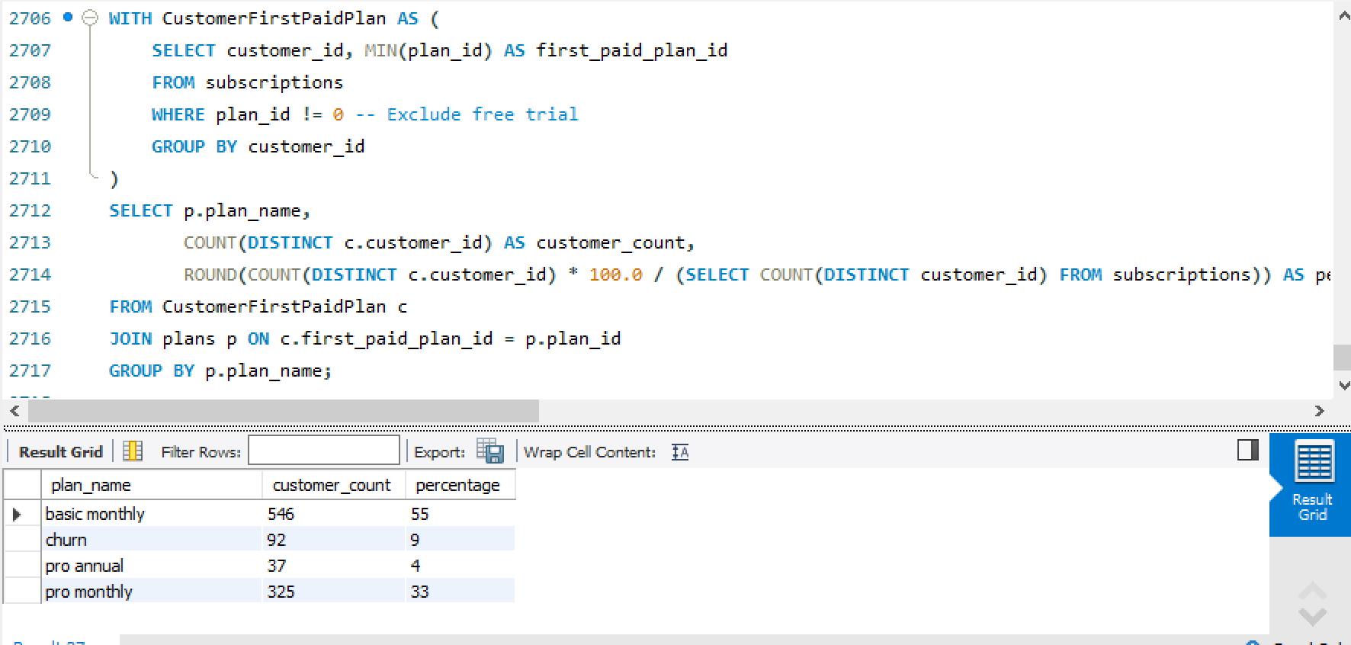

**QUESTION: 7**

**What is the customer count and percentage breakdown of all 5 plan_name values at 2020-12-**

**31?**

**QUERY**

**WITH cte1 AS (**

**SELECT *, RANK() OVER(PARTITION BY customer_id ORDER BY start_date DESC) AS ranking**

**FROM subscriptions**

**WHERE start_date <= '2020-12-31'**

**),**

**cte2 AS (**

**SELECT p.plan_name, COUNT(cte1.plan_id) AS num_plans**

**FROM cte1 INNER JOIN plans p**

**ON cte1.plan_id = p.plan_id**

**WHERE cte1.ranking = 1**

**GROUP BY p.plan_name**

**ORDER BY num_plans DESC**

**)**

**SELECT plan_name, num_plans,**

**ROUND((num_plans/(SUM(num_plans) OVER())*100), 2) AS pct_plans**

**FROM cte2**

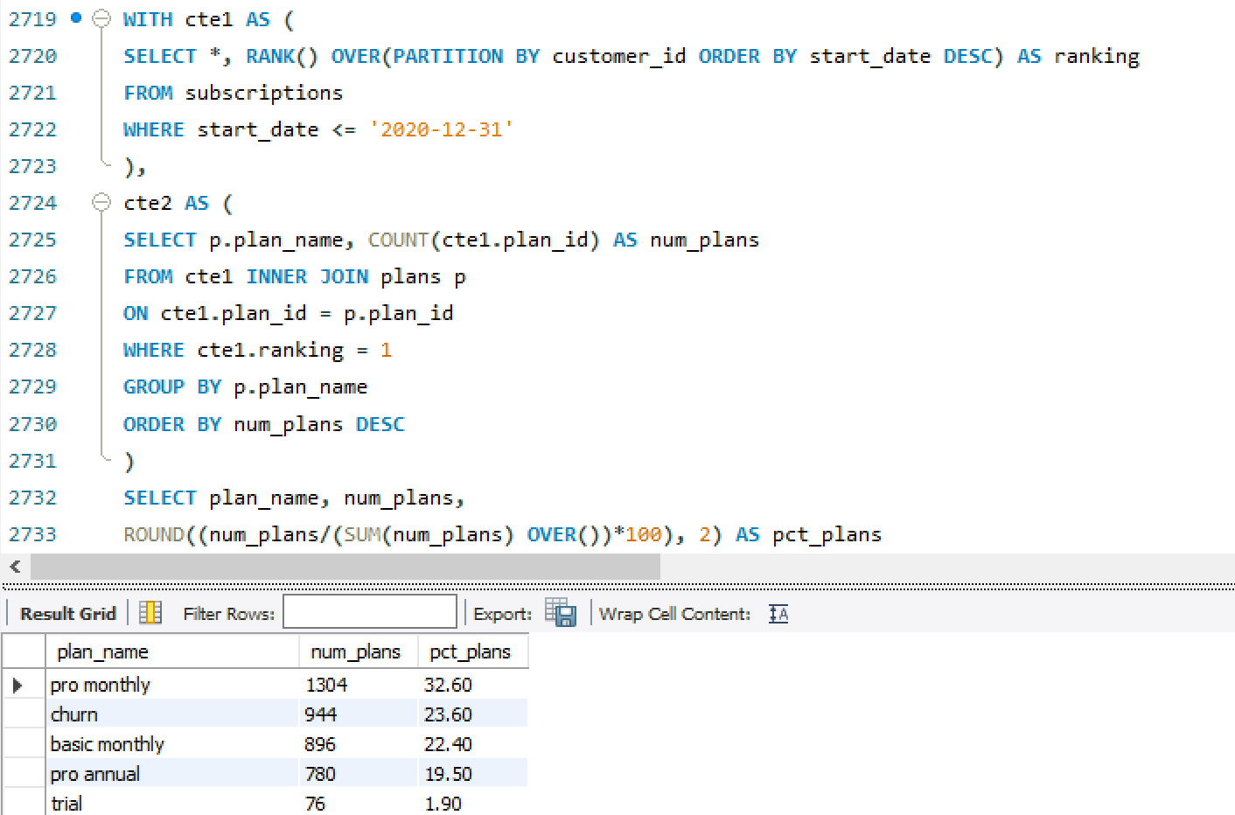

**QUESTION: 8**

**How many customers have upgraded to an annual plan in 2020?**

**QUERY**

**SELECT COUNT(DISTINCT s.customer_id) AS num_customers**

**FROM subscriptions sINNER JOIN plans p**

**ON s.plan_id = p.plan_id**

**WHERE p.plan_name = "pro annual" AND YEAR(s.start_date) = 2020;**

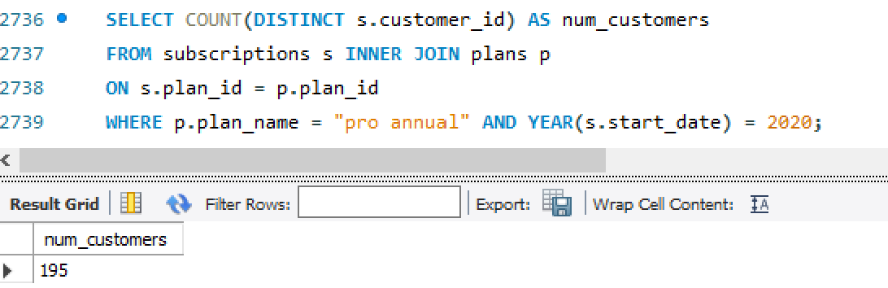

**QUESTION: 9**

**How many days on average does it take for a customer to an annual plan from the day they join**

**Foodie-Fi?**

**QUERY**

**WITH cte1 AS (**

**SELECT * FROM subscriptions**

**WHERE plan_id = 0**

**),**

**cte2 AS (**

**SELECT * FROM subscriptions**

**WHERE plan_id = 3**

**)**

**SELECT ROUND(AVG(DATEDIFF(cte2.start_date, cte1.start_date)), 1) AS avg_days**

**FROM cte1 JOIN cte2**

**ON cte1.customer_id = cte2.customer_id;**

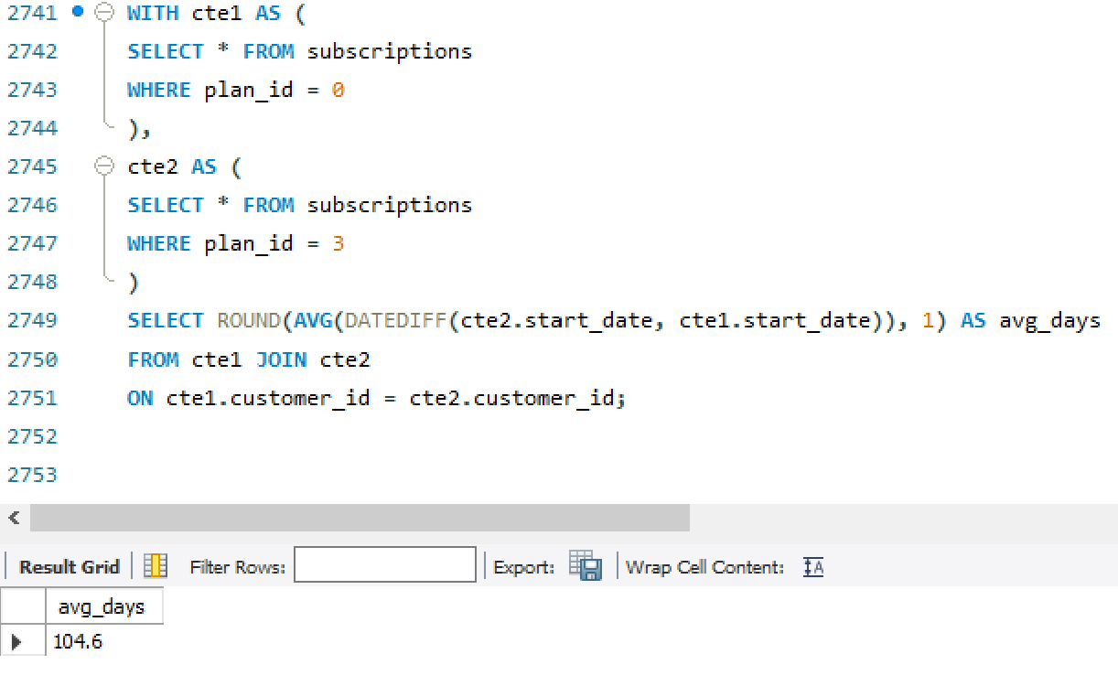

**QUESTION: 10**

**Can you further breakdown this average value into 30 day periods (i.e. 0-30 days, 31-60 days**

**etc)**

**QUERY**

**SELECT**

**CASE**

**WHEN days_difference >= 0 AND days_difference <= 30 THEN '0-30 days'**

**WHEN days_difference > 30 AND days_difference <= 60 THEN '31-60 days'**

**ELSE 'More than 60 days'**

**END AS period,**

**COUNT(customer_id) AS No_of_customers,**

**AVG(days_difference) AS AVG_Days_to_reach_annual_program**

**FROM (**

**SELECT**

**s2.customer_id,**

**DATEDIFF(**

**(SELECT MIN(start_date) FROM subscriptions AS s1 WHERE s1.customer_id = s2.customer_id AND**

**plan_id = 3),**

**(SELECT MIN(start_date) FROM subscriptions AS s3 WHERE s3.customer_id = s2.customer_id)) AS**

**days_difference**

**FROM subscriptions AS s2 WHERE plan_id ! = 3 AND plan_id ! = 4) AS differences**

**GROUP BY period**

**ORDER BY period;**

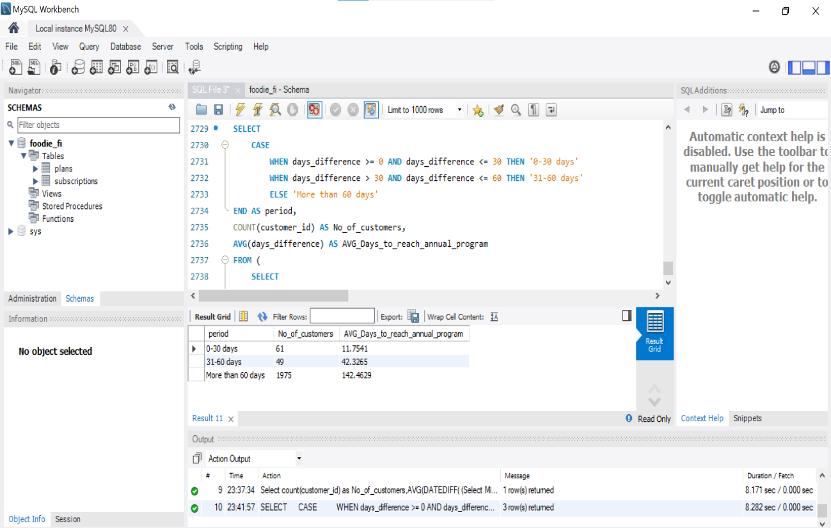

**QUESTION: 11**

**How many customers downgraded from a pro monthly to a basic monthly plan in 2020?**

**QUERY**

**select plan_id, count(distinct customer_id) as downgraded_from_annual_to_basic from**

**subscriptions**

**where plan_id =1**

**and customer_id in**

**(select distinct customer_id from subscriptions where plan_id=2 and year(start_date) = 2020);**

